Synchronous Frequency Measurement System(SFMS)
Implementation Specification
Version 1.0.0
System Name: |  | Synchronous Frequency Measurement System(SFMS)
Responsible Peer Team: TRO Control Systems
Prepared by: |  |  |  | Feb 08 2007
Prepared by: | Jian Zuo (Ryan)  Operations Application Analysis |  |  | Date
Reviewed by: | Ritchie Carroll
Reviewed by: |  |  |  | Date
Approved by:
Approved by: |  |  |  | Date

Revision History

Date | Version | Description of Revision | Author
Feb 8, 2007 | 1.0.0 | Initial Document | Jian Zuo(Ryan)

Table of Contents
1 Purpose 1
1.1 Scope 1
2 Client Goals 1
2.1 Collect and store data from multiple streaming frequency measurement devices 1
2.2 Provide frequency data for visual display via visualization tools 1
2.3 Provide interface for data analysis and triangulation for locating disturbances 1
2.4 Manage metadata about measurement devices 1
3 Definitions 2
4 System Diagram 3
5 Protocol Description 4
5.1 Virginia Tech FNET Protocol 4
5.2 IEEE Std 1344 1995 4
5.2.1 Data frame 5
5.2.2 Configuration frame 6
5.3 IEEE Std C37. 118 7
6 Class Structure 7
6.1 FNET Protocol 9
6.1.1 Overview 9
6.1.2 Class Common 10
6.1.3 Class FrameParser 11
6.1.4 Class ConfigurationFrame 11
6.1.5 Class ConfigurationCellConnection 12
6.1.6 Class DataFrame 13
6.1.7 Class DataCellConnection 13
6.1.8 Class DataCell 13
6.1.9 Enumeration Elements 15
6.1.10 Class FrequencyDefinition 15
6.1.11 Class FrequencyValue 15
6.1.12 Class PhasorDefinition 16
6.1.13 Class PhasorValue 16
7 Business Process Diagram 19

Synchronous Frequency Measurement System(SFMS)

Purpose
The purpose of the Implementation Specification is to describe the implementation detail of the protocols, which are supported by Synchronous Frequency Measurement System (SFMS), including the protocol definition, data structure and additional feature etc..

Scope
This project includes the application development activities necessary to complete the SFMS.

Client Goals
The Synchronous Frequency Measurement System (SFMS) will
- gather data from several different types of instruments (e.g., Phasor Measurement Units (PMU), Digital Fault Recorders (DFR), Frequency Disturbance Recorder (FDR) and Power Quality (PQ) meters),
- condense the data streaming from each unit down to a single large stream of time-stamped frequency measurements, and then
- combine all of the measurements from multiple units into a single binary data stream for transmission to other applications and users, as well as for storage in its own database.
The SFMS will ignore all non-frequency measurement data from the units’ data records.

Collect and store data from multiple streaming frequency measurement devices
The SFMS will be able to receive concentrated stream data, i.e., multiple devices in a single input stream, streams from single devices, and raw data equally, storing the data so that other tools can retrieve and process the data. The S.F.M.S. will support three protocols: IEEE Std 1344, IEEE C37. 118 and Virginia Tech FNET

Provide frequency data for visual display via visualization tools
The SFMS will store data so that data consumers (e.g., EPRI, TVA, Virginia Tech, etc.) will be able to generate a graphical display of near real-time frequency conditions.

Provide interface for data analysis and triangulation for locating disturbances
The SFMS will store data so that significant variances in the frequency measurements can be identified and the source of each variance can be quickly located by triangulation of relevant measurement devices. It is expected that Virginia Tech will provide the application to calculate the locations and magnitude of these disturbances.

Manage metadata about measurement devices
The SFMS will store unique identifiers of measurement devices for cross referencing with additional information about measurement data points.

Definitions
Phasor Measurement Unit (PMU) - Device that extracts line-frequency phase angle and magnitude data from sensor signals. This class of instruments is most commonly associated with time-synchronized monitoring.
Digital Fault Recorder (DFR) - Device that samples and stores analog and related binary sensor data during power system transients for later replay and analysis. Directional Overcurrent relaying is necessary for the protection of multiple-source feeders, when it is essential to limit the tripping of faults in only one direction. Fault directional control is possible for faults on each phase, as well as the neutral. Directional current sensing and control requires a voltage, current, or a dual polarizing signal for selective detection of the direction or phase of the fault current. If directional overcurrent control is enabled, the overcurrent protection is inhibited for faults in the non-trip direction.
Power Quality (PQ) Meter - Device that monitors and measures any power concern manifested in voltage, current or frequency deviation that results in failure or mis-operation of customer equipment. Examples include: over-voltage conditions (surges), under-voltage conditions (sags or brownout), no voltage conditions (blackout), transient voltages (spikes, dropouts, ringing), harmonics, frequency variations, flicker conditions, etc. Power quality is always measured within the electrical system as to its effects on sensitive electrical components and equipment and is by definition not a measure of electrical exposure to humans or animals.

System Diagram
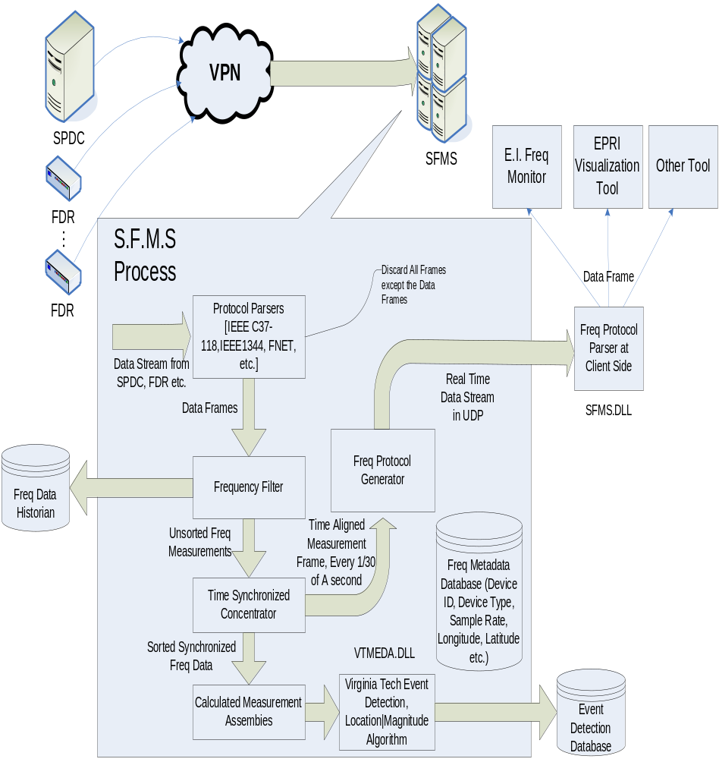
Figure 1 S.F.M.S. System Diagram
Variable data sources including PMU, DFR, PQ and FDR etc. are transmitting data to S.F.M.S. The Protocol Parses will handle different kinds of data stream and convert them to unique data format. The Frequency Filter will filter out redundant data, like voltage, current and digital value etc., except the frequency data and time stamp. Then the frequency data will be passed to storage database and Time synchronized Concentrator. Sorted frequency data will be consumed by internal application and external application. The internal applications include event detection and event location estimation etc. The data for external application will be encapsulated by Frequency Protocol Generator and be sent out to remote clients as binary image, through UDP protocol. The clients at remote side will decode the binary stream by Frequency Protocol Parser and retrieve the frequency and time stamp for further application like frequency visualization etc.

Protocol Description

Virginia Tech FNET Protocol
Virginia Tech FNET is deployed at distribution level. The device Frequency Disturbance Recorder (FDR) is connected to the wall outlet. The device always works like client and the S.F.M.S. will works as server. Particular ports will be opened at server side, which listen the requests form FDRs. When the connection is estimated, the data frame, which contains the UnitId, Date, Time, Sub-second, Analog value, Frequency, voltage and angle, will be transmitted to server. FDRs have no configuration frame. Below is the format of FDR data frame:
Table 1 Virginia Tech FNET Protocol Data Frame Format
Unit ID | Date (mmddyy) | Time(UTC hhmmss) | Sub  Second | Analog  Value | Frequency | Voltage  Magnitude | Angle

For example:
21 53006 205926 1 60.0240 60.0265 119.1449 5.3154
The frame rate is 10 frames /second and therefore the sub second is from 1 to 10 indicating 100ms to 1000ms. The Analog Value can be treated as space holder; however it will transmit the GPS position coordinators through the first three packets of the first second of each minute in following order: Longitude, Latitude and the tracked satellite number. The data frames are encoded as ASCII code. ASCII code 0x01 and 0x00 represent the beginning and the end of the data frame respectively. The voltage magnitude and the angle together represent the phasor in polar format. The nominated voltage level is 120v and nominated frequency is 60 Hz. The angle is in radius (0~ 2π).
To make the Virginia Tech FNET protocol compliant with other protocols, virtual configuration frame will be created.

IEEE Std 1344 1995
The IEEE Std 1344 defined three kinds of frames: Data Frame, Configuration Frame and head frame which are distinguished by the byte of SMPCNT as shown below:
Table 2 –SMPCNT word definition (message type is defined by the three most significant bits)
Bit 15-14-13 | Frame Type | Definitions
000 | Data frame | Bits 0-12:sample count 0-8191
001 | Head frame | Bit 12:first frame flag(0: first frame of head file, 1: continuing frame)  Bit 11:last frame flag(0: not last frame, 1 last frame of file)
010 | Configuration Frame | Bit 12:first frame (0:first frame of configuration file,1 continuing frame)  Bit 11: last frame flag (0:not the last frame, 1: last frame of file)  Bit 0-10:frame count 0-2047, first frame is count 0)
011-100 | Reserved for expansion | Bit 0-12 : to be assigned
101-111 | User define | Bit 0-12:user define

Data frame
A data frame is identified by the three most significant bits of the third word (5th byte) equal to zero. The following is the data frame structure:
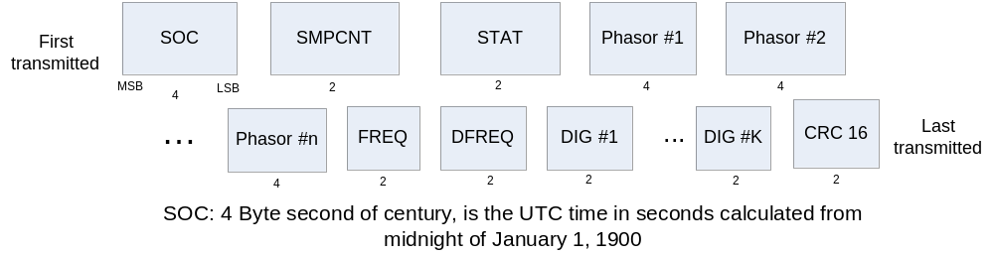
Figure 2—Data Frame for Phasor Data

Table 3—Status Word STAT definition
STAT bits | Definition
Bit 15 | Synchronization status (0:valid, 1:invalid)
Bit 14 | Data integrity (0:valid data, 1: invalid data)
Bit 13-11 | Trigger Status:  111: Frequency trigger  110: df/dt trigger  101: Angle trigger  100: Overcurrent trigger  011: Undervoltage trigger  000-001:Unused, user defined
Bit 10-0 | Number of bytes in frame including SOC, SMPCNT,STAT and CRC16, 10-2047

If the phasor is in real and imaginary format, each shall be a two’s complement, 16 b binary number, with the scale defined by the configuration file. If the phasor is in magnitude and angle format, the magnitude shall be a 16 b binary number in the range 0 to 2¹⁵-1; and, the angle shall be in radius × 10⁻⁴ in the range –π to +π. The frequency (FREQ) is a 16 b binary number in Hz × 10⁻³ deviation from system nominal. The system nominal frequency shall be given in the configuration file. The range shall be -32.767 to +32.767 Hz. The rate-of-change of frequency (DFREQ) shall be the rate of change in Hz per second × 10⁻². The 16 b number thus defines a range of -327.67 to +327.67 Hz/s. The digital channel data shall reflect the state of the digital inputs (binary 0 or binary 1). The configuration file defines whether 0 or 1 is the normal state. Digital inputs shall be assigned starting at the least significant bit (b0) of digital channel word. Zeros shall be inserted in unused bits.

Configuration frame
The configuration file shall have the following information:
- Station name and identification
- Number of phasors
- Number of digital channels
- Channel and phasor naumes, units, and conversion factors
- Nominal line frequency
- Transmission period in number of fundamental frequency cycles
There are two types of configuration files: a system configuration file CFG-1, and a data configuration file CFG-2. The CFG-1 file shall indicate all possible inputs. The CFG-2 shall indicate the phasors actually being sent since only a subset of available phasor may be transmitted by the PMU in the data frame. All fields shall be fixed length and no delimiters shall be used.

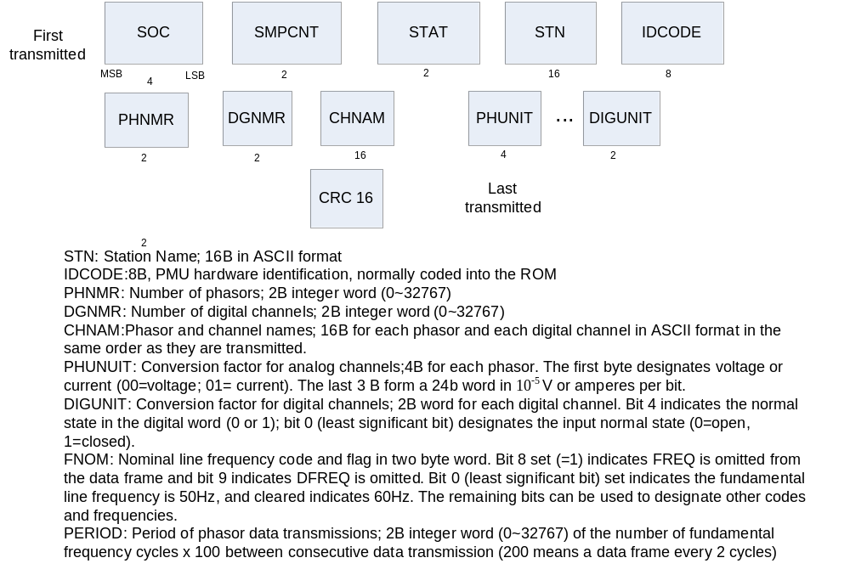
The configuration file may be sent in several frames. The overall transmission has the organization shown in figure 4 but the configuration file data from STN through PERIOD may be broken into multiple frames. Each frame shall start with SOC, SMPCNT, and STAT, and end with CRC₁₆.

IEEE Std C37. 118

Class Structure
All of the protocols have data frame, configuration frame and head frame or some of them. The frames are based on Cell. Therefore we can extract the common part of all of the three protocols as defined Channel. And based on Channel, we derived Cell and Frame. The following is the interface diagram:
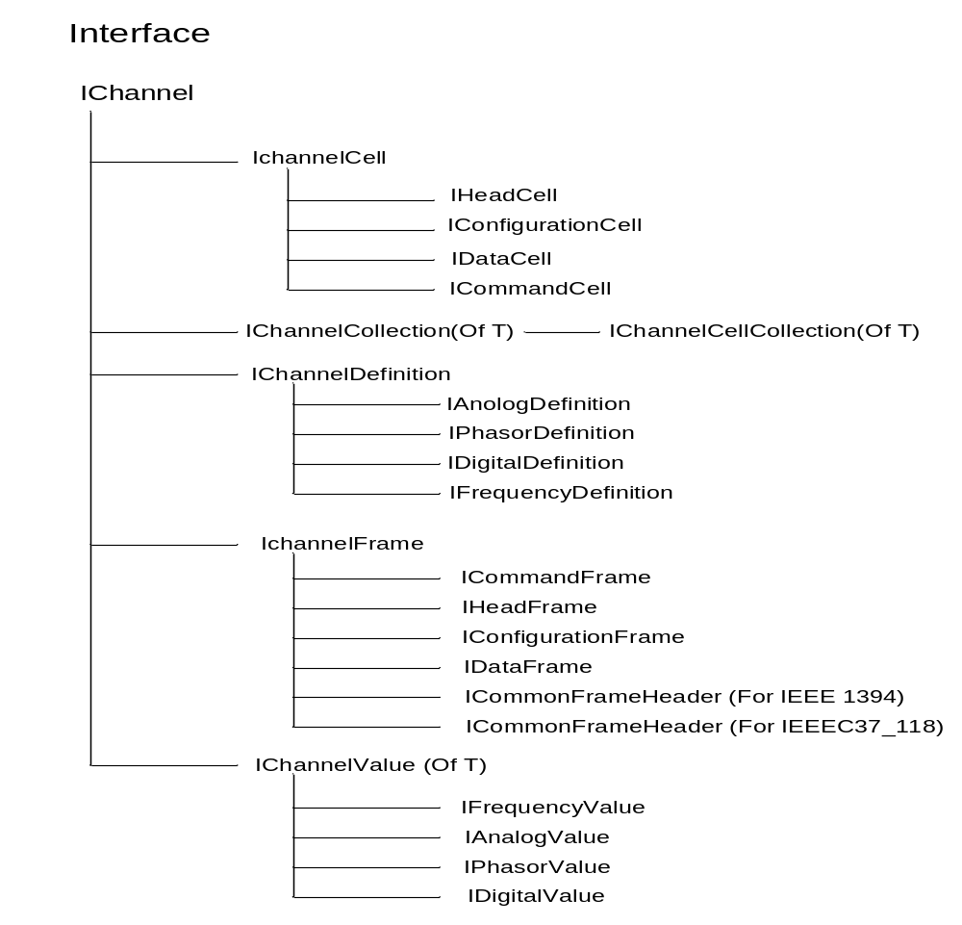
The implementation of the interface is the basic class, shown in the following diagram:
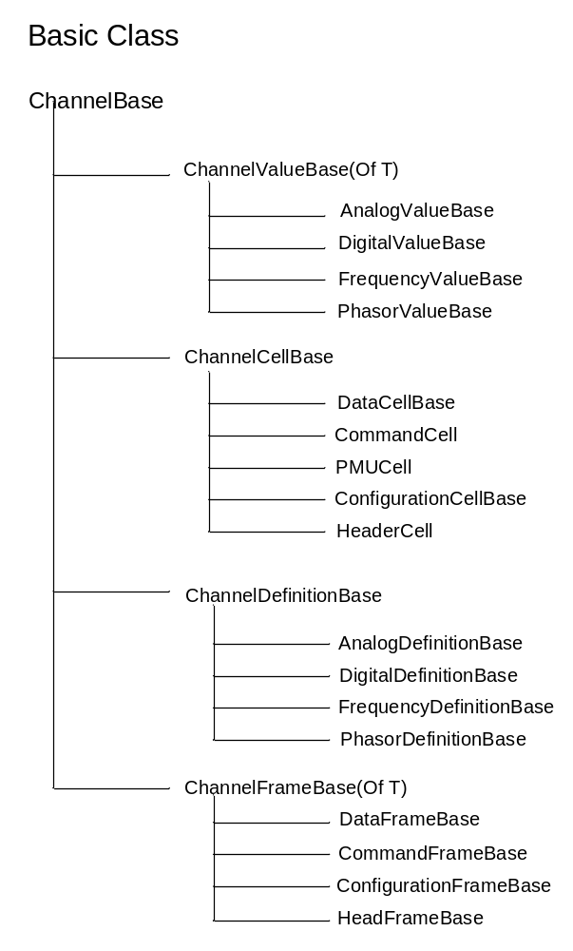
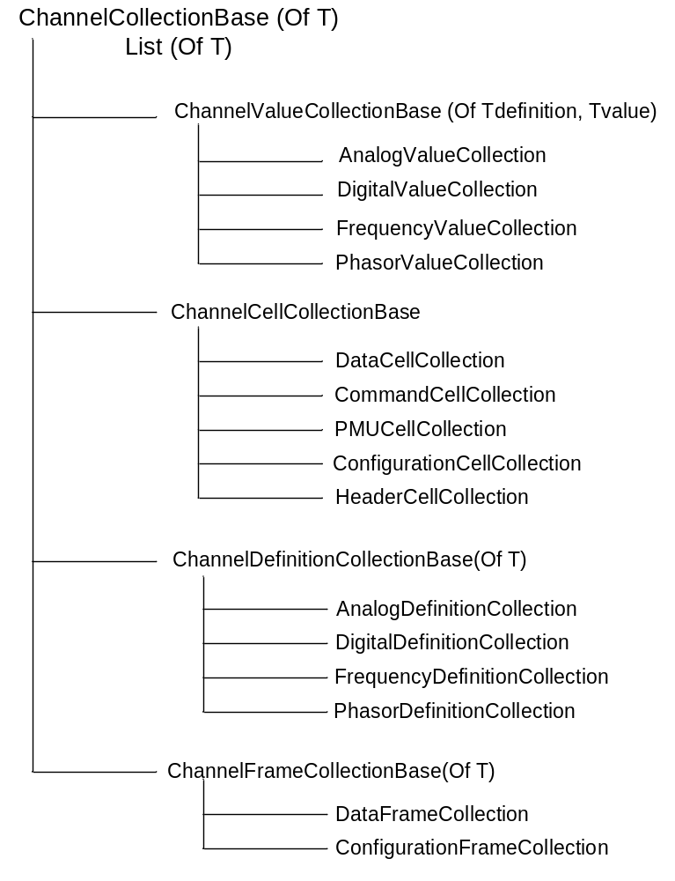

FNET Protocol

Overview
FNET protocol’s implementation is based on the base classes. Since FNET has no configuration frame, we need to generate a virtual configuration frame when the first time we phase the data frame. All the classes in FNET is derived from basic class aforementioned except the class Common and FrameParser, please see the diagram below:
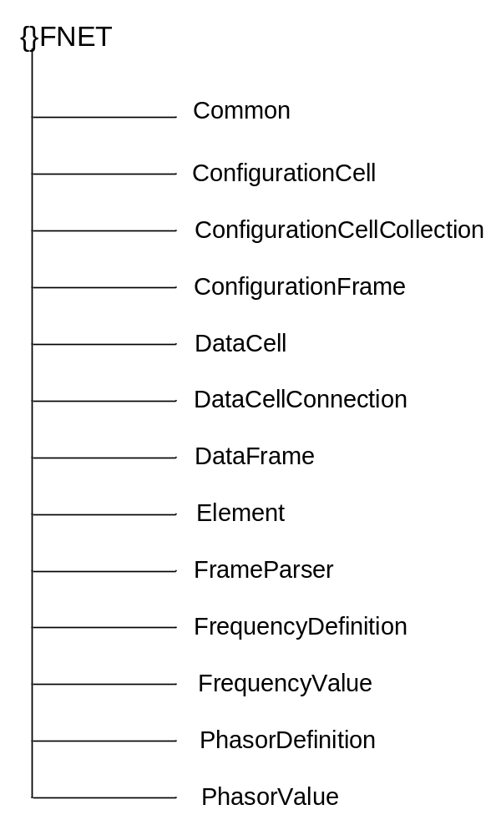

Class Common
The Common class only contains global functions and parameters and it is no need to be instantiated.
Public NotInheritable Class Common
Private Sub New()
End Sub
'Data frame start byte
Public Const StartByte As Byte = &H1
'Data frame start byte
Public Const EndByte As Byte = &H0
'Absolute maximum number of possible phasor values that could fit
into a data frame
Public Const MaximumPhasorValues As Int32 = 1
'Absolute maximum number of possible analog values that could fit
into a data frame,no analogvalue
Public Const MaximumAnalogValues As Int32 = 0
'Absolute maximum number of possible digital values that could fit
into a data frame, no digital value
Public Const MaximumDigitalValues As Int32 = 0
End Class

Class FrameParser
The Class FrameParser is response for:
- Checking if a completed frame arrived.
- If a completed frame is arrived, choose corresponding method to parser different kinds of frame (data frame or configuration frame etc.). FNET has no configuration frame; therefore, we will create a virtual configuration frame when the first data frame is arrived.
- After processing the frames, raise corresponding event to notify other modules. If exceptions encountered, raise exceptions as well.
Public Class FrameParser
Inherits FrameParserBase
' This event is raised when a Configuration Frame has been parsed
Public Event ReceivedConfigurationFrame( . . .)
' This event is raised when a Data Frame has been parsed
Public Event ReceivedDataFrame(. . .)
' Parse the Frame
Protected Overrides Sub ParseFrame(ByVal buffer() As Byte, ByVal
offset As Integer, ByVal length As Integer, ByRef parsedFrameLength
As Integer)
' Pseudo Code
For Index in Buffer
If Find_A_Compelete_Frame Then
RaiseReceivedFrameBufferImage
If No_configuration_frame Then
Create_New_Configuration_frame
RaiseReceivingConfigurationFrame
End If
RaiseReceivingDataFrame
'Define actual parsed frame length so base class can increment
'offset past end of data frame
Return_paresedFrameLength
End Sub
End Class

Class ConfigurationFrame
The Class ConfigurationFrame is response for
- Set Station name, FrequencyDefinition, PhasorDefinition.
- Set and Get Property Longitude, Latitude and Numberof Satellite

Public Class ConfigurationFrame
Inherits ConfigurationFrameBase

Public Sub New(ByVal idCode As UInt16, ByVal ticks As Long, ByVal frameRate
As Int16, ByVal nominalFrequency As LineFrequency, ByVal stationName As
String)
Set_Station_Name
Create_FrequencyDefinition
Create_PhasorDefinition
End Sub
'Set and Get the property of Longitude
Public Property Longitude() As Single
Get
Return Cells(0).Longitude
End Get
Set(ByVal value As Single)
Cells(0).Longitude = value
End Set
End Property
'Set and Get the property of Latitude
Public Property Latitude() As Single
Get
Return Cells(0).Latitude
End Get
Set(ByVal value As Single)
Cells(0).Latitude = value
End Set
End Property
'Set and Get the property of NumberOfSatellites
Public Property NumberOfSatellites() As Integer
Get
Return Cells(0).NumberOfSatellites
End Get
Set(ByVal value As Integer)
Cells(0).NumberOfSatellites = value
End Set
End Property
End Class

Class ConfigurationCellConnection
The Class ConfigurationCellConnection is connection of ConfigurationCell. Please see the code for more detail

Class ConfigurationCell
The Class ConfigurationCell is response for
- Set the value of m_longitude, m_latitude and m_numberOfSatellites
- Serialize and de-serialize the configuration data
- Output the Attributes
- Check the data formats (Phasor Coordinate Format, Frequency Data Format and Analog Data Format)
'Deserialize configuration cell and retrieve the Longitude, Latitude and
number of Satellites
Protected Sub New(ByVal info As SerializationInfo, ByVal context As
StreamingContext)

MyBase.New(info, context)
m_longitude = info.GetSingle("longitude")
m_latitude = info.GetSingle("latitude")
m_numberOfSatellites = info.GetInt32("numberOfSatellites")

End Sub

'Serialize configuration cell
Public Overrides Sub GetObjectData(ByVal info
System.Runtime.Serialization.SerializationInfo, ByVal context As
System.Runtime.Serialization.StreamingContext)

MyBase.GetObjectData(info, context)

' Serialize configuration cell
info.AddValue("longitude", m_longitude)
info.AddValue("latitude", m_latitude)
info.AddValue("numberOfSatellites", m_numberOfSatellites)

End Sub
'Retrieve the Attributes
Public Overrides ReadOnly Property Attributes() As Dictionary(Of String,
String)
Get
Dim baseAttributes As Dictionary(Of String, String) =
MyBase.Attributes
With baseAttributes
.Add("Longitude", Longitude)
.Add("Latitude", Latitude)
.Add("Number of Satellites", NumberOfSatellites)
End With

Return baseAttributes
End Get
End Property

Class DataFrame
The Class DataFrame is response for
1) Set and retrieve m_sampleindex which is the sub second of the time stamp
2) Output data Attributes
3) Load the phase function of DataCell to process the data image

'Load the DataCell phase function to process the data image
Public Sub New(ByVal configurationFrame As ConfigurationFrame, ByVal
binaryImage As Byte(), ByVal startIndex As Int32)

MyBase.New(New DataFrameParsingState(New DataCellCollection, 0,
configurationFrame,AddressOf FNet.DataCell.CreateNewDataCell),
binaryImage, startIndex)

End Sub

Class DataCellConnection
The Class DataCellConnection is the connection of DataCell

Class DataCell
The Class DataCell is response for
- Phase the binary image
- Phase the time stamp
- Output Attributes include “FNET Date”, “FNET Time”, “Analog Value”

Public Class DataCell
Inherits DataCellBase

'Parse the binary image
Protected Overrides Sub ParseBodyImage(ByVal state As
IChannelParsingState, ByVal binaryImage As Byte(), ByVal startIndex As
Int32)

'Pseudo Code
If binaryImage_Is_not_valid Then Throw exceptions
End If
Data= Convert_the_binary_image_to_data_array
'Retrieve the Longitude, Latitude and NumberOfSatellite
'information from Ánalog value
If Data(Second_of_time) equal “00” Then
Select Case SampleIndex
Case 0
Longitude
Case 1
Latitude
Case 2
NumberOfSatellites
End Select
End If
Frequency = Retrieve_frequency(Data)
Phasor = Retrieve_phasor (Data)
'frameRate is the rate of frame /sec
TimeTick = ParseTimestamp (Data(date),Data(time),sampleIndex,
frameRate)
End Sub
'Convert the data, time and sampleIndex to TimeTick
Private Function ParseTimestamp(ByVal fnetDate As String, ByVal
fnetTime As String, ByVal sampleIndex As Integer, ByVal frameRate As
Integer) As Long
fnetDate = fnetDate.PadLeft(6, "0"c)
'If the sampleIndex(subsecond) equal to 10, the second should be
'added one
If sampleIndex = 10 Then
Return New Date( _
2000 + Convert.ToInt32(fnetDate.Substring(4, 2)), _
Convert.ToInt32(fnetDate.Substring(0, 2).Trim()), _
Convert.ToInt32(fnetDate.Substring(2, 2)), _
Convert.ToInt32(fnetTime.Substring(0, 2)), _
Convert.ToInt32(fnetTime.Substring(2, 2)), _
Convert.ToInt32(fnetTime.Substring(4, 2)), _
0).AddSeconds(1.0).Ticks
Else
Return New Date( _
2000 + Convert.ToInt32(fnetDate.Substring(4, 2)), _
Convert.ToInt32(fnetDate.Substring(0, 2).Trim()), _
Convert.ToInt32(fnetDate.Substring(2, 2)), _
Convert.ToInt32(fnetTime.Substring(0, 2)), _
Convert.ToInt32(fnetTime.Substring(2, 2)), _
Convert.ToInt32(fnetTime.Substring(4, 2)), _
Convert.ToInt32(sampleIndex / frameRate * 1000)).Ticks
End If
End Function

Enumeration Elements
This enumeration defines the component in FNET data frame, along the sequence of the components

Public Enum Element
UnitID
[Date]
Time
SampleIndex
Analog
Frequency
Voltage
Angle
End Enum

Class FrequencyDefinition
The class is derived from Class FrequencyDefinitionBase, which is derived from Class ChannelDefinitionBase. It will set and retrieve the parameters definite frequency type:

"dfdtScale" : the scale factor of df/dt (m_dfdtScale)
"dfdtOffset" : the offset of df/dt (m_dfdtOffset)
"Label": the label of frequency (m_label)
"Index"”: the index of frequency (m_index)
"Offset": the offset of frequency (m_offset)
"Scaling Factor": the scaling factor of frequency (m_scale)
"Scale per Bit": the scale per bit (Return 0.00001F)
Typical scale/bit is 10^-5
"Maximum Scaling Factor":
the Maximum Scaling Factor (Return &H1FFFFFF)
Typical scaling/conversion factors should fit within 3
bytes (i.e., 24 bits) of space
"Conversion Factor" :
the factor for conversion (Return m_scale * ScalePerBit)
"Maximum Label Length":
Typical label length is 16 characters (Return 16)

Class FrequencyValue
The class is derived from Class FrequencyValueBase, which is derived from Class ChannelValueBase. It will set and retrieve the frequency value includes:
"Frequency Value": Frequency (m_frequency)
"df/dt Value": Df/Dt of Frequency (m_dfdt)
"Unscaled Frequency Value" :
Public Overridable Property UnscaledFrequency() As Int16 Implements IFrequencyValue.UnscaledFrequency
Get
With Definition
Return Convert.ToInt16((m_frequency - .Offset) * .ScalingFactor)
End With
End Get
Set(ByVal value As Int16)
With Definition
m_frequency = value / .ScalingFactor + .Offset
End With
End Set
End Property

"Unscaled df/dt Value":
Public Overridable Property UnscaledDfDt() As Int16 Implements IFrequencyValue.UnscaledDfDt
Get
With Definition
Return Convert.ToInt16((m_dfdt - .DfDtOffset) * .DfDtScalingFactor)
End With
End Get
Set(ByVal value As Int16)
With Definition
m_dfdt = value / .DfDtScalingFactor + .DfDtOffset
End With
End Set
End Property

Class PhasorDefinition
The class is derived from Class PhasorDefinitionBase, which is derived from the class ChannelDefinitionBase. It will set and retrieve the parameters definiting Phasor type includes:
"type": the type of Phasor,voltage of current (m_type)
"voltageReference":
Protected Sub New(ByVal parent As IConfigurationCell, ByVal index As Int32, ByVal label As String, ByVal scale As Int32, ByVal offset As Single, ByVal type As PhasorType, ByVal voltageReference As IPhasorDefinition)
MyBase.New(parent, index, label, scale, offset)
m_type = type
If type = PhasorType.Voltage Then
m_voltageReference = Me
Else
m_voltageReference = voltageReference
End If

End Sub

Class PhasorValue
The class is derived from Class PhasorValueBase, which is derived from the class ChannelValueBase. It is response for:
- Set and retrieve imaginary and real part of phasor
- Convert complex number format of Phasor to polar format
"Angle Value": Set and retrive the angle from complex format
Public Overridable Property Angle() As Single Implements IPhasorValue.Angle
Get
Return System.Math.Atan2(m_imaginary, m_real) * RadiansToDegrees
End Get
Set(ByVal value As Single)
m_compositeValues(CompositePhasorValue.Angle) = value
' If all composite values have been received, we can calculate
phasor's real and imaginary values
CalculatePhasorValueFromComposites()
End Set
End Property

"Magnitude Value": Set and retrive the magnitude from complex format
Public Overridable Property Magnitude() As Single Implements IPhasorValue.Magnitude
Get
Return System.Math.Sqrt(m_real * m_real + m_imaginary * m_imaginary)
End Get
Set(ByVal value As Single)
m_compositeValues(CompositePhasorValue.Magnitude) = value
' If all composite values have been received, we can calculate
phasor's real and imaginary values
CalculatePhasorValueFromComposites()
End Set
End Property

"Real Value": Set and retrieve the real part of phasor (m_real)
"Imaginary Value":Set and retrieve the imaginary part of phasor (m_imaginary)

"Unscaled Real Value": Set and retrive the unscalded real part of the phasor
Public Overridable Property UnscaledReal() As Int16 Implements
IPhasorValue.UnscaledReal
Get
Return Convert.ToInt16(m_real / Definition.ConversionFactor)
End Get
Set(ByVal value As Int16)
m_real = value * Definition.ConversionFactor
End Set
End Property

"Unscaled Imaginary Value":Set and retrieve the unscaled imaginary part of the phasor
Public Overridable Property UnscaledImaginary() As Int16 Implements
IPhasorValue.UnscaledImaginary
Get
Return Convert.ToInt16(m_imaginary / Definition.ConversionFactor)
End Get
Set(ByVal value As Int16)
m_imaginary = value * Definition.ConversionFactor
End Set
End Property

"Angle Value was Received": return the value indicating if the angle value has been received
"Magnitude Value was Received": return the value indicating if the magnitude value has been received

Business Process Diagram
